COSC 436 Dierbach

Spring 2017

**ASSIGNMENT 3 – Implementing the Decorator Design Pattern**

**(with Strategy Pattern and Factory Class)**

150 pts.

**PROBLEM**

You are to design and implement code based on the Decorator pattern for generating an appropriate receipt for a customer buying items at a particular Best Buy store. The general format of a receipt is as follows:

Basic Receipt

Store Header (store street address, state abbreviation, phone number, store number) Date of Sale

Itemized Purchases

Total Sale (without sales tax) Amount Due (with added sales tax)

Dynamically-Added Items

Tax Computation object (based on state residing in)

Optional Secondary Headers (“Greetings”) to be printed at the very top of the receipt,

e.g.,

- “Happy Holidays from Best Buy”

- “Summer Sales are Hot at Best Buy”

Relevant Rebate Forms (to be printed at the end of the receipt) Promotional Coupons (to be printed at the end of the receipt)

e.g., “10% off next purchase of $100 or more” coupon

**APPROACH**

We will assume that the code is written as part of the software used by all Best Buy stores around the country. Therefore, the information in the Store Header will vary depending on the particular store's location. In addition, the amount of sales tax (if any) is determined by the state that the store resides in, and included in a receipt by use of the Strategy pattern. The added items to be displayed on each receipt (i.e.,. greeting secondary header, rebate form or coupon) will be handled by use of the Decorator pattern. Finally, the receipt will be constructed by use of the Factory class pattern.

Basic Receipt

The information for the basic receipt should be stored in a BasicReceipt object (see below). The instance variables of a BasicReceipt should contain the date of sale, a PurchasedItems object, the total sale (without tax) and amount due (with added tax), each of type float. In addition, following the Strategy design pattern, there should be an instance variable of (interface) type TaxComputation that can be assigned the appropriate tax computation object (e.g., MDTaxComputation) for the state that the store resides in.

Determining Sales Tax

We will implement tax computation classes so that receipts can be generated for one of five possible states: Alabama (4%), Delaware (no sales tax), Georgia (4%), Maryland (6%) and Missouri (4.225%). Note that a number of states have a “sales tax holidays” in which certain items are not taxed (e.g., clothers, computers) in preparation of the new school year. These holidays normally last for 2-4 days over at weekend at the end of summer (e.g., the first weekend in August). Use the information provided in Wikipedia about states with a tax holiday ([here)](http://en.wikipedia.org/wiki/Sales_tax_holiday) to implement a state computation object that would properly compute the sales tax of a given state, for a certain set of purchased items, for the current or any future year. (Note that we will assume that anything purchased in Best Buy is a computer-related item.)

Adding Additional Receipt Items

There are a number of different “add on” items that may need to be printed with the basic receipt.

During particular times of the year, a receipt header may begin with a special greeting (e.g., “Happy Holidays from Best Buy”), called a secondary header, to be added to the top of a receipt. In addition, rebate forms may be printed at the end of a receipt if a purchased item has a mail-in rebate. Finally, coupons may be printed (also at the end of a receipt) if the total purchase exceeds a certain dollar amount (e.g., if spend over $100, get a 10% off coupon for the next visit).

Objects of interface type AddOn are used to store the added printout for a receipt. The interface has two methods - applies (which is passed a PurchasedItems object containing all of the items for the current receipt), and getLines (which returns the added lines of text to be printed as a single String with embedded newline characters). For AddOn objects of type SecondaryHeader, applies always returns true. This is because if a SecondaryHeader exists, it is always added to the (top) of the receipt. Since rebates only apply to a specific item, method applies returns true if and only if the particular item is found in PurchasedItems. A similar approach is taken for adding coupons to the end of a receipt, except that coupons apply if and only if the customer has spent over a certain amount.

We assume that each Best Buy store downloads the current set of decorator objects each morning.

Configuration File

A configuration file will be read by the program at start up, to configure the system for the particular store location, containing the following information: store street address, state abbreviation, phone number, and store number.

Factory Class

You must utilize a factory class to properly construct Best Buy receipts based on the information read from the configuration file, and the particular items purchased.

A UML class diagram for the design of this program is given below.

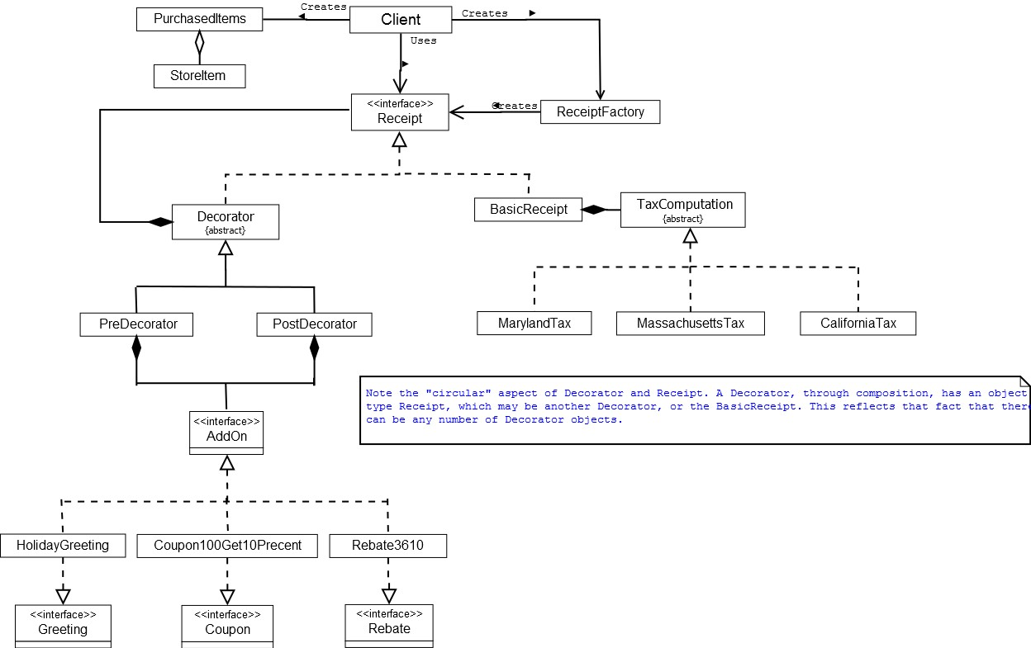

3

**INTERFACES AND CLASSES TO UTILIZE**

Following are the interface and classes to be used in the design of the program.

Interfaces

public interface Receipt { // type of all receipt components (i.e., BasicReceipt and receipt decorators)

public void prtReceipt();

}

public interface AddOn { // the type of added info to a BasicReceipt (e.g., greetings, rebates, coupons)

public boolean applies(PurchasedItems items);

public String getLines();

}

public interface SecondaryHeading { // marker interface, i.e., nothing to implement

}

public interface Rebate { // marker interface, i.e., nothing to implement

}

public interface Coupon { // marker interface, i.e., nothing to implement

}

Abstract Classes

public abstract class Decorator implements Receipt {

private Receipt trailer;

public Decorator(Receipt r) {

trailer = r;

}

protected void callTrailer() {

trailer.prtReceipt();

}

public abstract void prtReceipt();

}

public abstract class TaxComputation {

public abstract double computeTax(PurchasedItems items, ReceiptDate date);

public abstract boolean taxHoliday();

}

StoreItem Class

public class StoreItem {

private String itemCode; // e.g., 3010 private String itemDescription; // e.g., Dell Laptop private String itemPrice;

public StoreItem(String code, String descript, String price)

{ ... }

// appropriate getters, setters and toString method

}

PurchasedItems Class

public class PurchasedItems {

private ArrayList<StoreItem> items;

public PurchasedItems() {

items = new ArrayList();

}

public void addItem(StoreItem item) { ... }

public double getTotalCost() { ... }

public boolean containsItem(String itemCode) { ... }

}

BasicReceipt Class

public class BasicReceipt implements Receipt {

private String storeInfo; // store number, store address, phone number private String stateAbbrev; // AL, DE, GA, MD, or MO

private PurchasedItems items;

private Date date;

private TaxComputation tc;

public BasicReceipt(PurchasedItems items) {

this.items = items;

}

public void setTaxComputation(TaxComputation tc) { this.tc = tc; }

public void setDate(String date) { this.date = date; }

public void prtReceipt() {

// to implement

}

}

AddOn Classes

Each of these classes is implemented to provide the information for a particular secondary header, rebate or coupon. The following are *examples only* of what these classes may be.

public class HolidayGreeting implements AddOn, SecondaryHeading {

public boolean applies(PurchasedItems items) {

return true; // SecondaryHeading decorators always applied

}

public String getLines() {

return “* Happy Holidays from Best Buy *”;

}

}

public class Rebate1406 implements AddOn, Rebate {

public boolean applies(PurchasedItems items) {

return items.containsItem(“1406”);

{

public String getLines() {

return “Mail-in Rebate for Item #1406\n” + “Name:\n” + “Address:\n\n” + “Mail to: Best Buy Rebates, P.O. Box 1400, Orlando, FL”;

}

}

public class Coupon100Get10Percent implements AddOn, Coupon { // similar to rebate class }

Decorator Classes

There are two decorator class types - one for displaying text at the top of a receipt (PreDecorator), and another for displaying information at the bottom of a receipt (PostDecorator). Each is constructed to contain an AddOn object, which provides the added information to be displayed on the receipt.

public class PreDecorator extends Decorator {

private AddOn a;

public PreDecorator(AddOn a, Receipt r) {

super(r);

this.a = a;

}

public void prtReceipt() { System.out.println(a.getLines()); callTrailer();

}

}

public class PostDecorator extends Decorator

// similar, except that prtReceipt print the add on information

// *after* the other parts of the receipt are printed

Tax Computation Classes

public class MDTaxComputation extends TaxComputation {

public double computeTax(PurchasedItems items, ReceiptDate date) {

// calls method taxHoliday as part of this computation

}

public boolean taxHoliday(ReceiptDate date);

// returns true if date of receipt within the state’s tax free holiday,

// else returns false. Supporting method of method computeTax.

}

Tax computation objects for other states are similar

Factory Class

public class ReceiptFactory {

final String best_buy_name = “BEST BUY”;

String store_num;

String street_addr; String phone; String state_code;

private TaxComputation[] taxComputationsObjs; // tax computation objects (one for each state)

private AddOn[] addOns; // secondary header, rebate and coupon add-ons

public ReceiptFactory() { // constructor

// 1. Populates array of StateComputation objects and array of AddOn objects (as if downloaded from the BestBuy server).

// 2. Reads config file to assign store_num, street_addr, phone, and state_code

// 3. Stores appropriate StateComputation object to be used on all receipts.

}

public getReceipt(PurchasedItems items) {

// 1. Sets the current date of the BasicReceipt.

// 2. Attaches the StateComputation object to the BasicReceipt (by call to the setComputation method of BasicReceipt).

// 3. Traverses over all AddOn objects, calling the applies method of each. If an AddOn object applies, then determines if the AddOn is of type SecondaryHeader, Rebate, or Coupon.

If of type SecondaryHeader, then creates a PreDecorator for the AddOn. If of type Rebate or

Coupon, then creates a PostDecorator, and links in the decorator object.

// 5. Assigns the state computation object for the state store residing in.

// 6. Returns decorated BasicReceipt object as type Receipt.

}

}

**CLIENT CODE**

public static void main(String[] args)

{

// 1. Creates a PurchasedItems object.

// 2. Constructs ReceiptFactory object.

// 3. Prompts user for items to purchase, storing each in PurchasedItems.

// 4. Calls the getReceipt method of the factory to obtain constructed receipt.

// 5. Prints receipt by call to method prtReceipt() of the returned receipt object.

// create Receipt factory

ReceiptFactory factory = new ReceiptFactory();

// get receipt date

// (get the current date by call to Java API)

while (!quit)

{

// create new PurchasedItems object

while (more purchased items)

{

// display all available products to user

(to be implemented)

// read selected item

(to be implemented)

// add to PurchasedItems

(to be completed)

}

Receipt receipt = factory.getReceipt(items, date);

receipt.prtReceipt();

// prompt if want to start a new receipt

(to be implemented)

}

}

**PROGRAM TO CREATE**

Create a program that will create of and display Best Buy receipts. The program should provide a main menu as in the following,

1 – Start New Receipt

2 – Add Items

3 – Display Receipt

4 – Quit

Vary the information in the configuration file and the AddOn objects stored in the ReceiptFactory to check that the factory builds the correct receipts for various situations (e.g., in which only a BasicReceipt is created; in which a Greeting AddOn exists; and in which various combinations of Coupon and Rebate AddOns exist).

**WHAT TO TURN IN:** Each of the source files, submitted as one zipped file.